**Setup: (things to do when starting each experiment)**

**7. Following the preparatory work, state the essen- tial physics of the experiment in your own words. List your experimental objectives and how they relate to the essential physics.**

**8. After listing the objectives, identify the proce- dures you will have to perform, the data you must obtain, and the required calibrations.**

**9. When starting a new experiment, sketch a block diagram of the apparatus and signal chain.**

**Experimental documentation: (recording your work)**

**10. Record extensive narrative of your experi- mental work, in and out of lab. Describe what you did, why you did it, what you saw, and what you did next. Note typical instrument settings so as to be able to quickly set up an experiment on subsequent days. Sketch waveforms at vari- ous places within the signal chain. This will help ensure your understanding of each component and permit you to rapidly identify equipment failure.**

**11. Tabulate data into columns with headings, units, and estimated measurement uncer- tainties. Tables of raw data are the core of your notebook, but it must be more than just a data log.**

**12. Identify the location of large data files or long analysis programs if they are too big to directly en- ter or tape into your notebook. Analysis scripts, functional forms for non-linear fits, etc. should al- ways be present in your notebook.**

**13. Don’t wait until after the lab session has ended to visually examine the quality of your data. Create hand drawn plots of data — with error bars — as they are acquired, not later. These ini- tial plots will inevitably save you time and frustra- tion in making sure that your data are reasonable and suggestive of the behavior you expect. ⋆The importance of making preliminary plots and analyses in real time cannot be overstated.⋆**

**14. Your notebook should contain your analysis, results, and conclusions. These should be doc- umented with narrative, formulas, computations, plots, and error estimates, just like in-lab work. Remember to annotate graphics with as much in- formation as possible about how they were created.**

**Tasks Completed 9/7/21**

Electronic Setup of Oscilloscope, Bin, and Detector

1. Connected high voltage to back of bin
2. Connected low voltage to back of bin
3. Turned on Bin
4. Connectect detector to Normal Research Amplifier 450. Tee’d off to oscilloscope.
5. Connected from Research Amplifier unipolar to MCB ADC In. ADC In tee’d off to oscilloscope.
6. Calibration 610 V and 40 coarse gain.

Took some background radiation data to see the

general curve of it. Noticed that cobalt and sodium will not fit in the domain if we use 40 coarse grained for them. Cesium is around 80% of the way of the domain at 40 coarse grain.

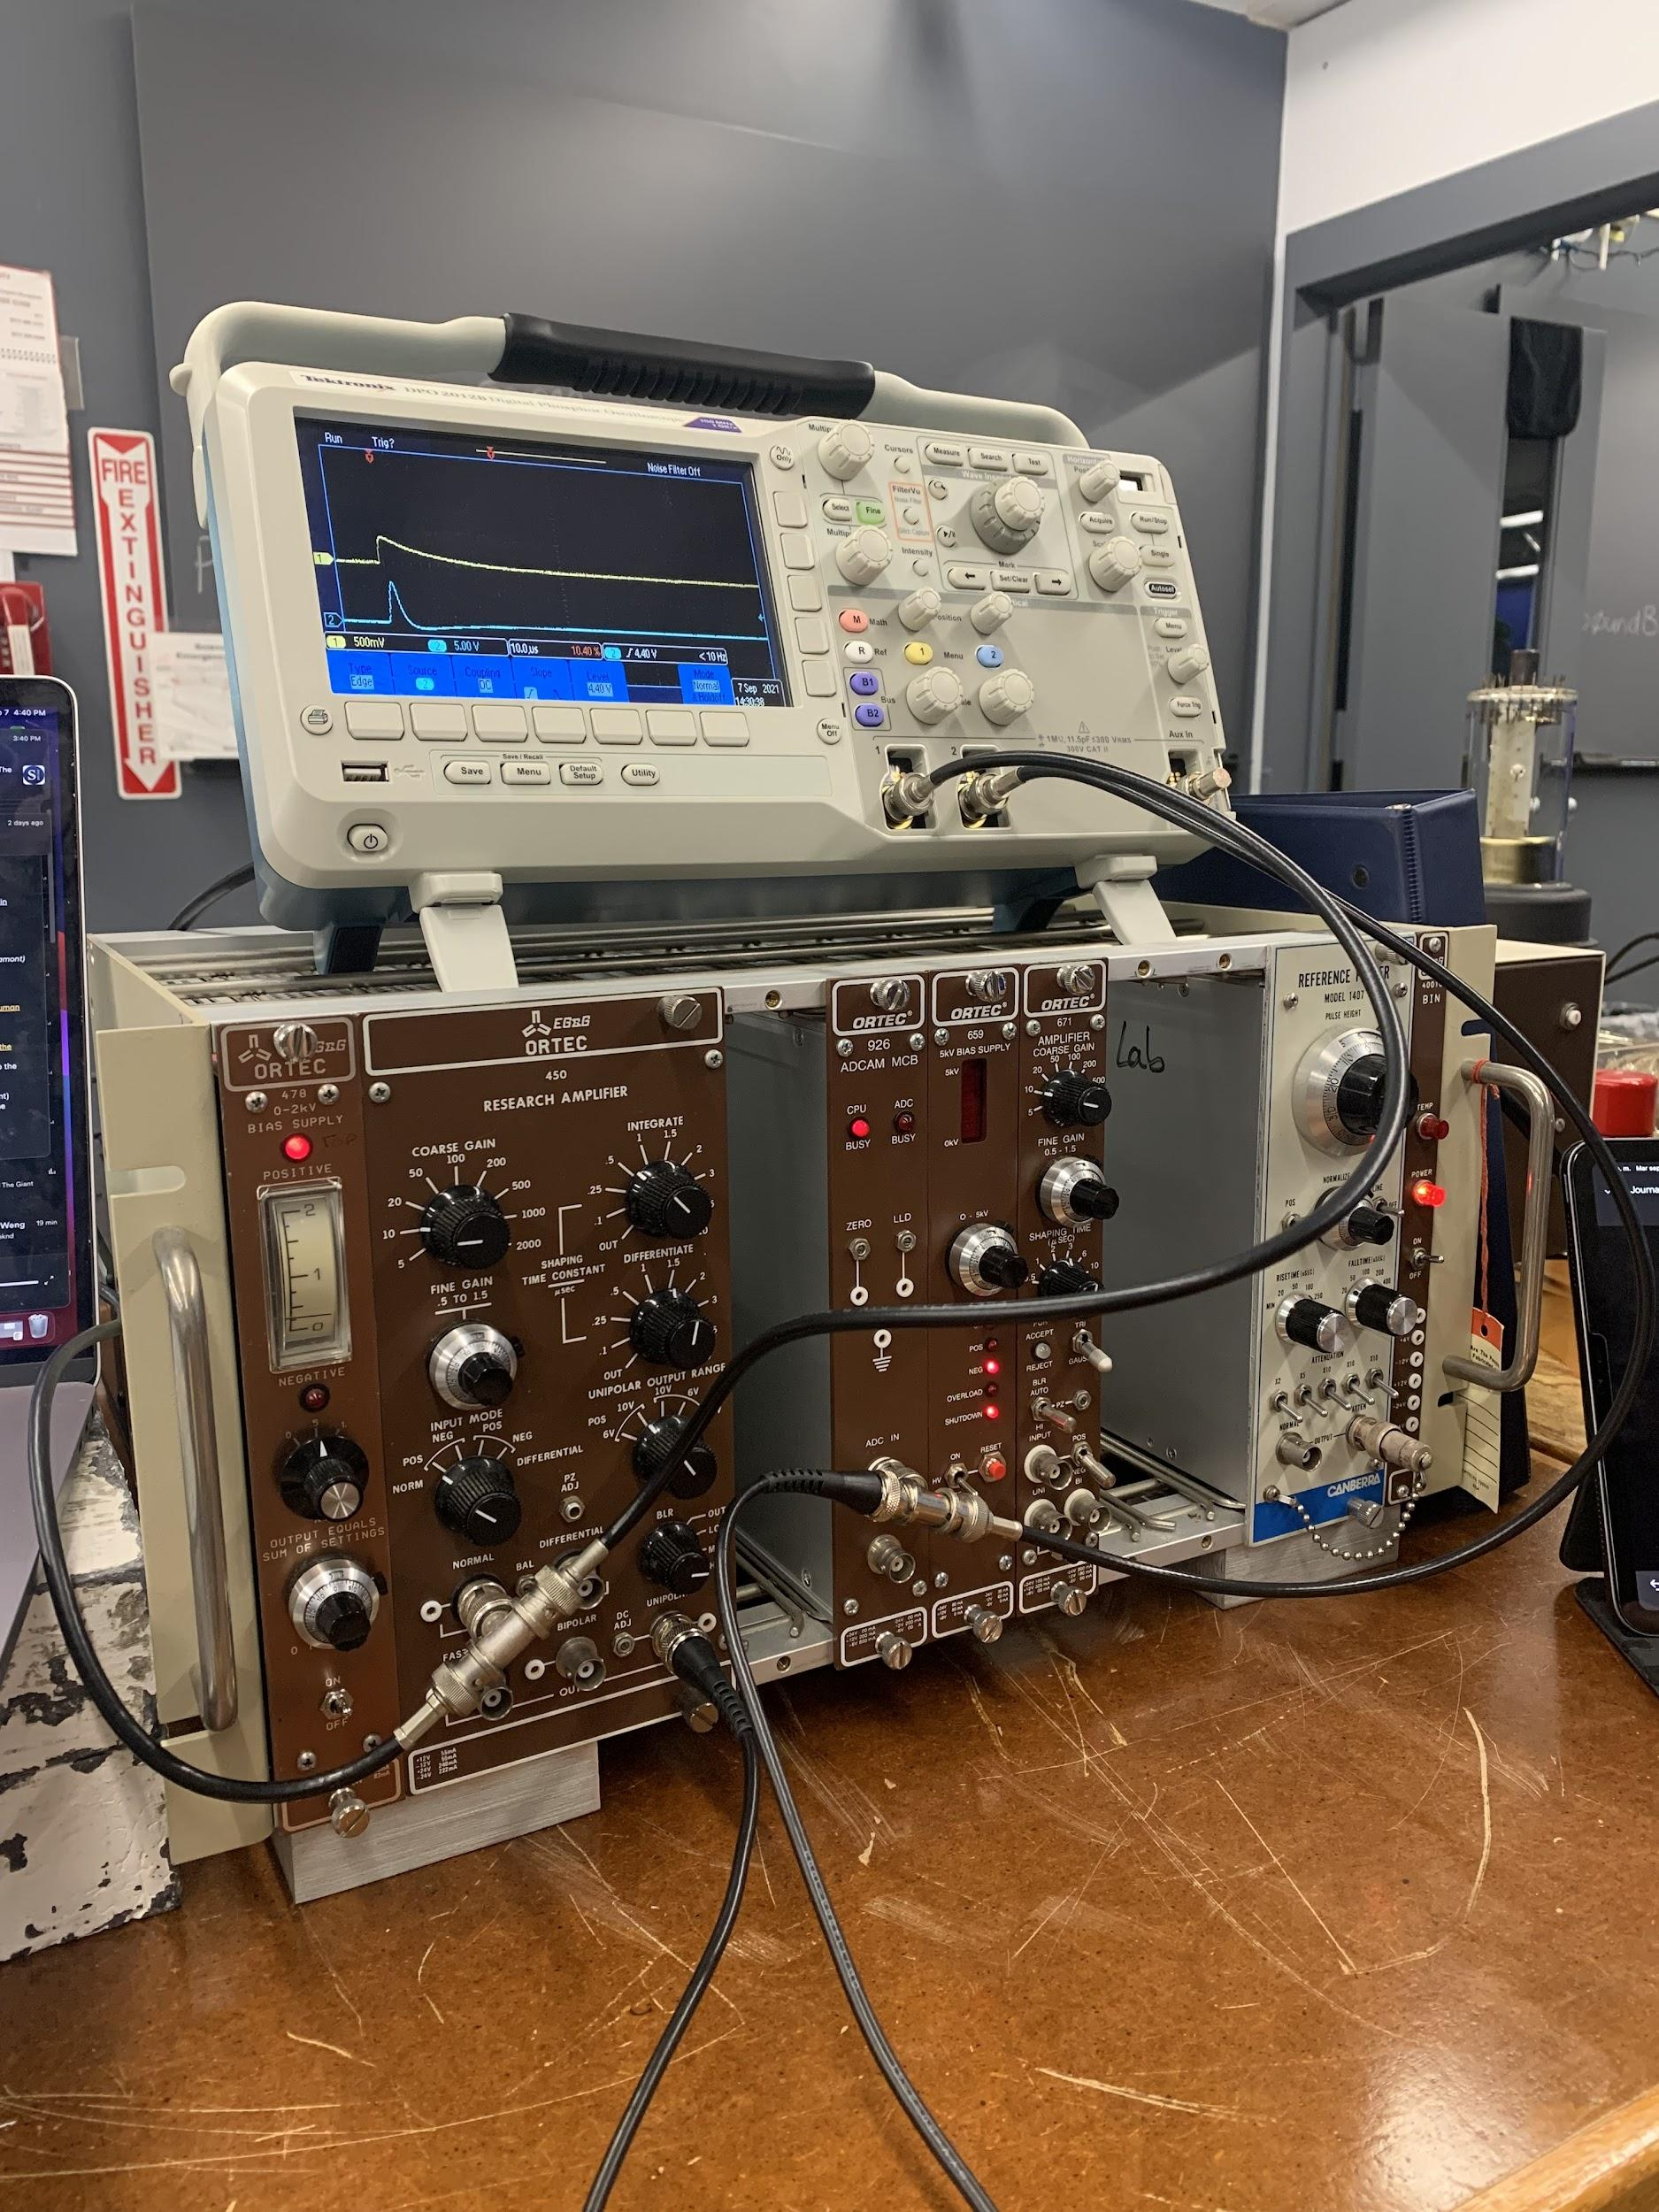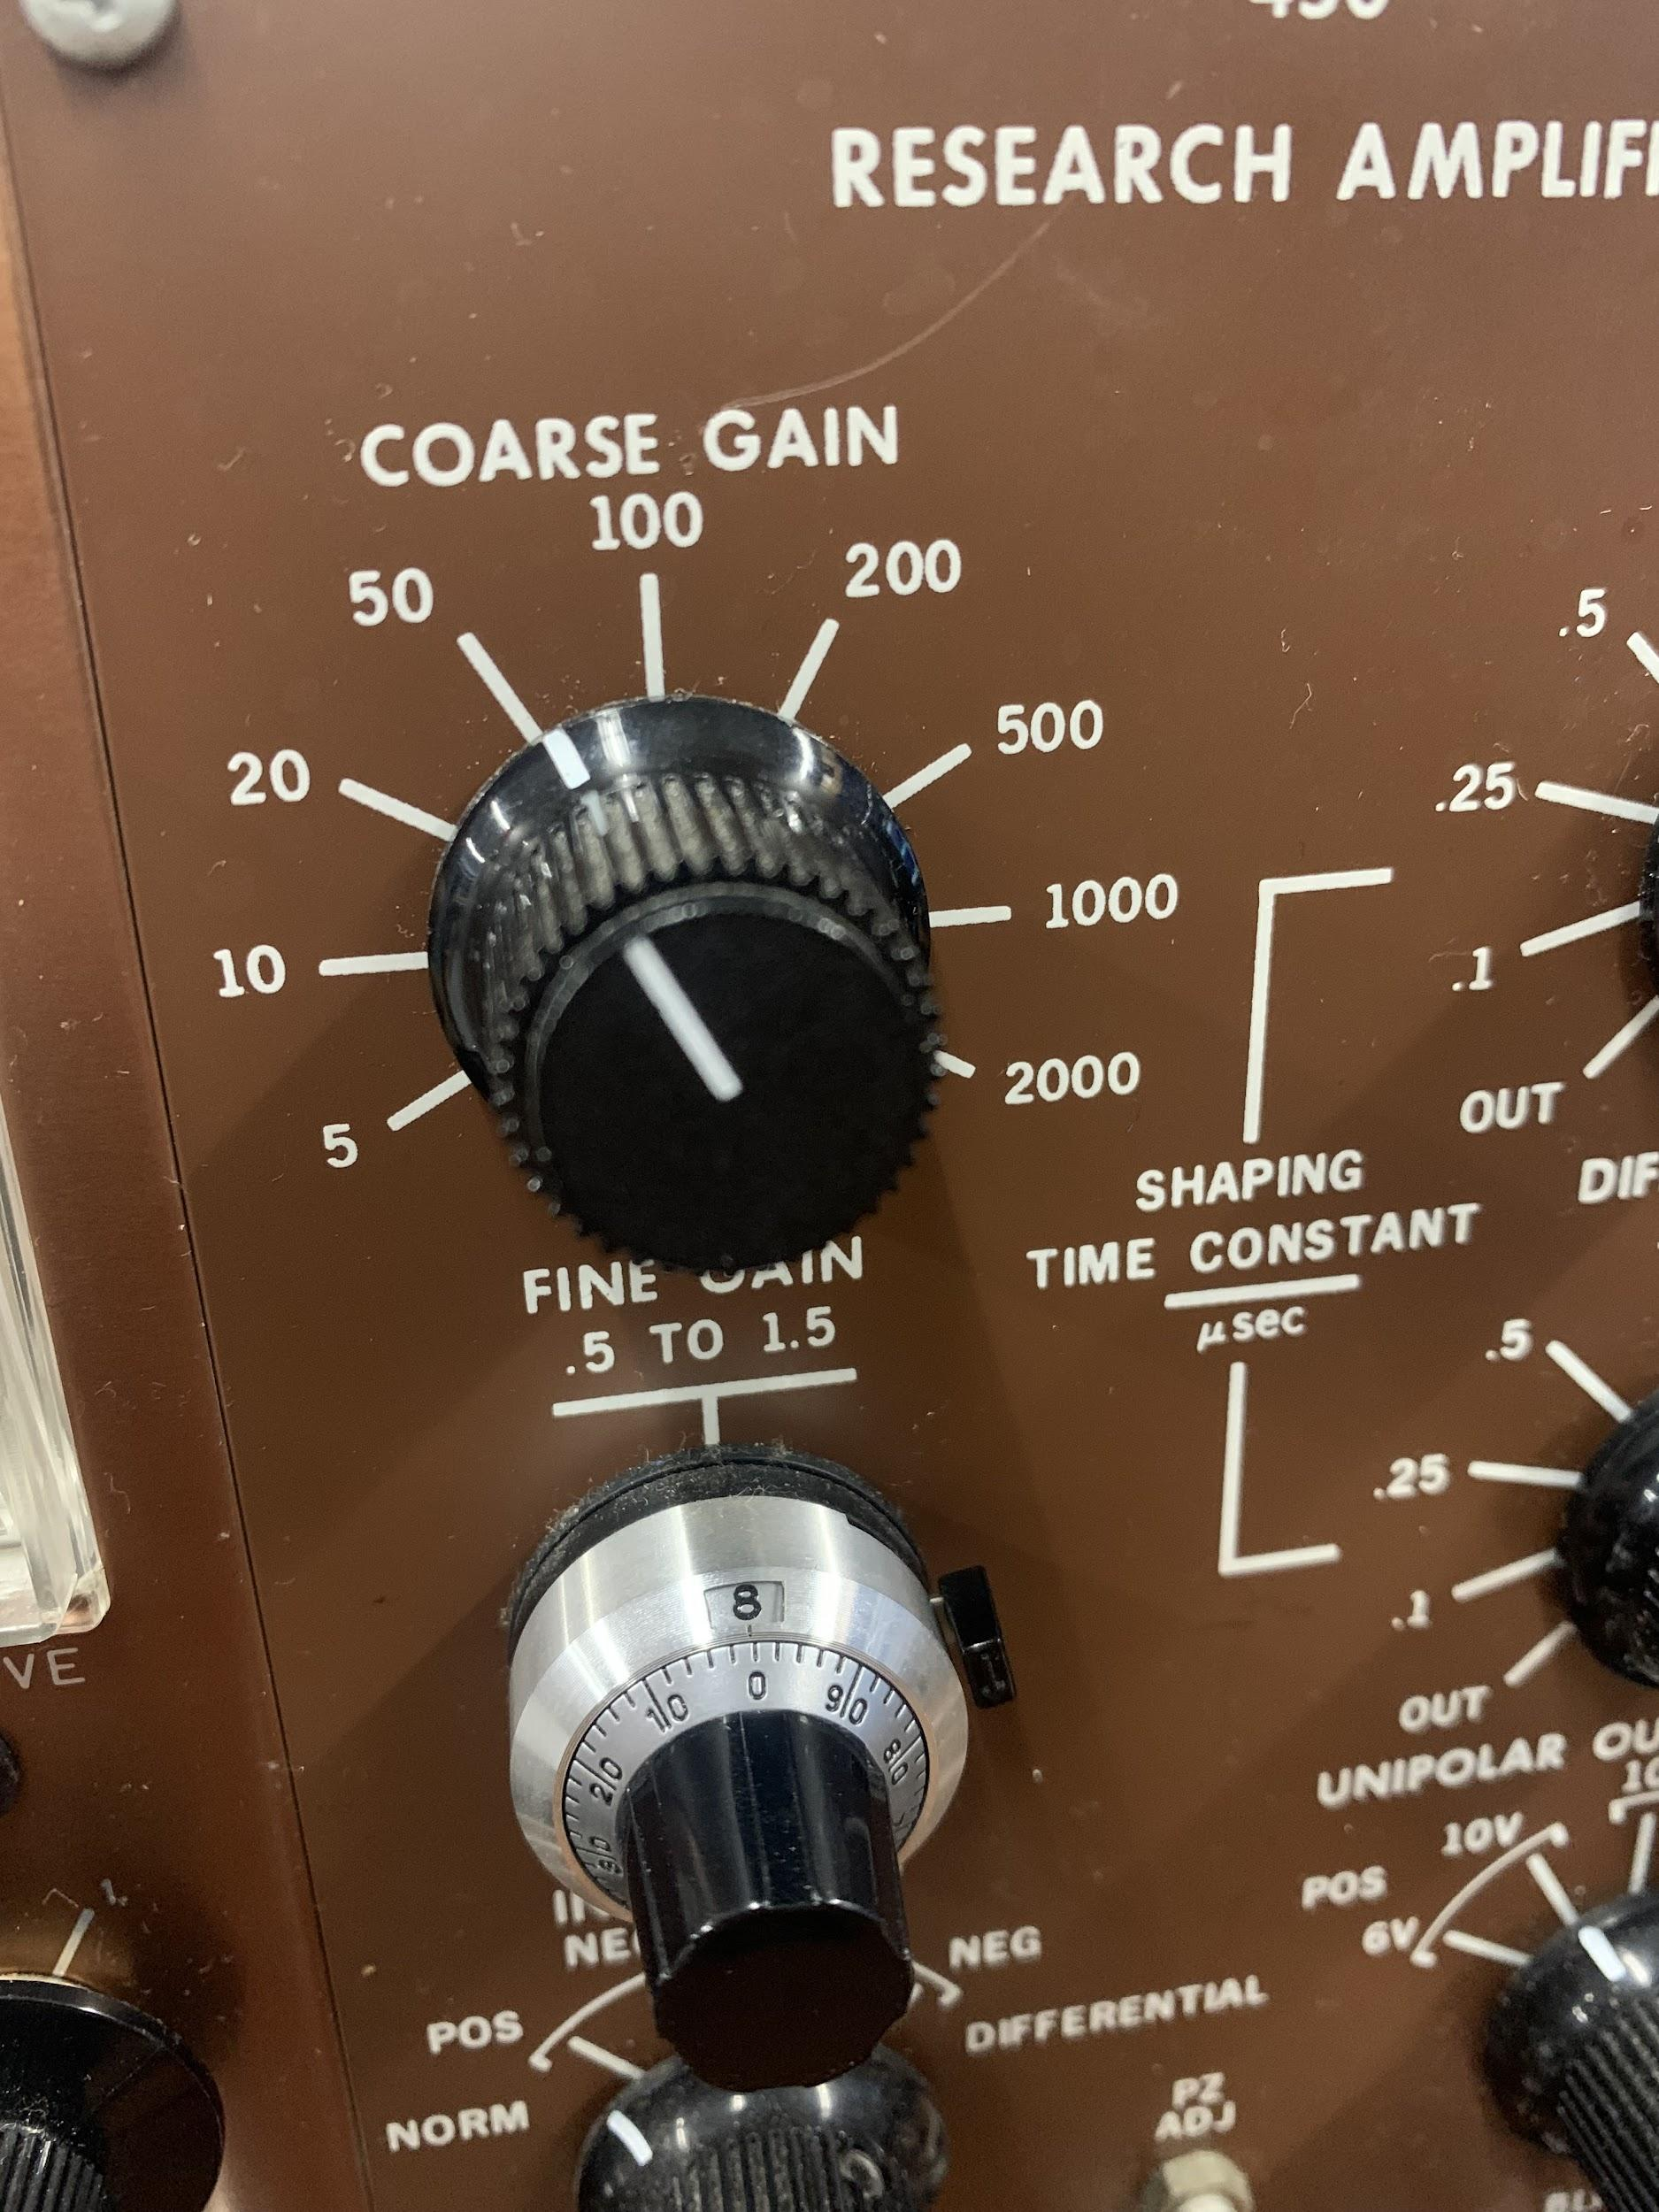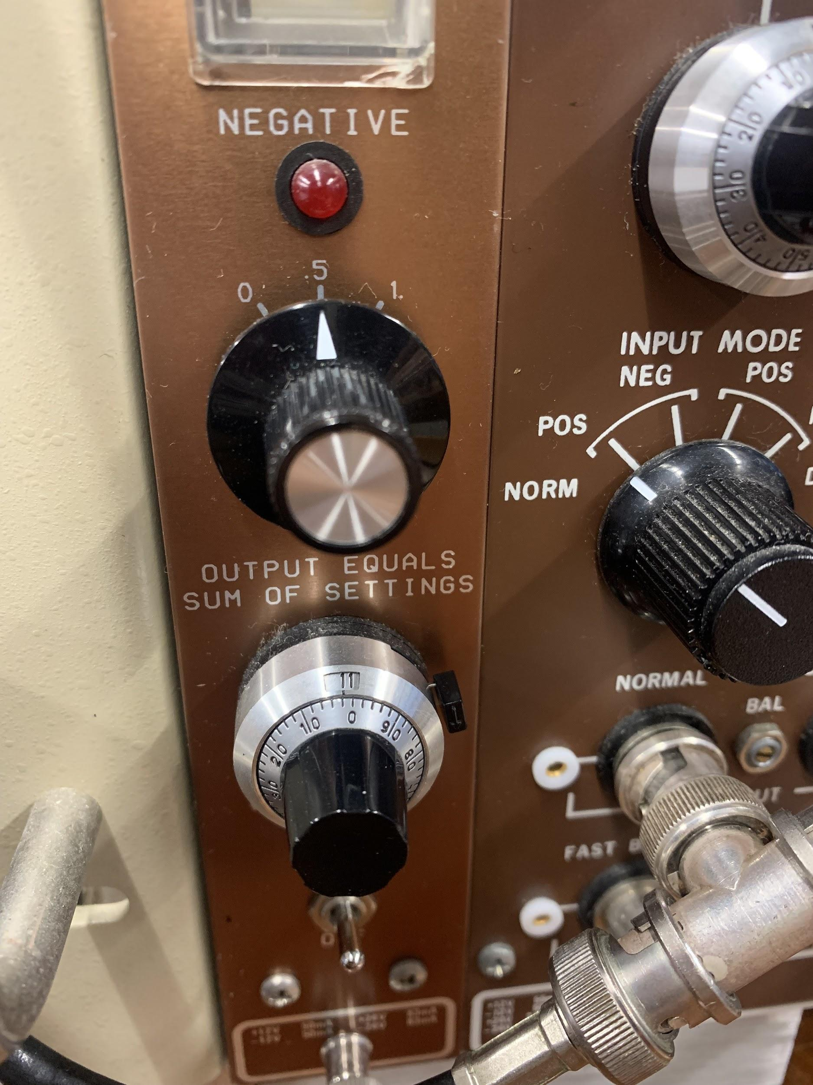

**Tasks Completed 9/9/21**

* Calibrate using 40 gain and 610 V for Americium, Cesium, and Barium
* Calibrate using cobalt and sodium, but change coarse gain at lower level to 20, leave the fine gain unchanged
* Plot data and get a line fit for calibration. Multiply the data for cobalt and sodium by some factor to scale the energies.
* Cesium in collimator data collection
* Cesium scattered by lead (3 angles), plastic (3 angles), aluminum

Save data as ASCII SPE instead of SPC. The time noted is in real time.

Live time: when detector is actively taking data instead of processing

1. Barium placed in front of the detector. Setting coarse gain to 50. Fine gain .8. Collected data for 120 sec.
   1. BariumCalibration40gain610volts120sec
2. Cesium placed in front of the detector. Setting coarse gain to 50. Fine gain .8. Collected data for 120 sec.
   1. Cesium Calibration40gain610volts120sec
3. Checking for destruction of PMT. Moved cesium right in front of the collimator.
   1. CesiumCalibration40gain610volts120secPMT
4. Background radiation for 120 sec
   1. BackgroundRadiation40gain610volts120sec
5. Americium placed in front of the detector. Setting coarse gain to 50. Fine gain .8. Collected data for 120 sec.
   1. AmericiumCalibration40gain610volts120sec
6. Sodium placed in front of the detector. Setting coarse gain to **20**. Fine gain .8. Collected data for 120 sec.
   1. SodiumCalibration16gain610volts120sec
7. Cobalt placed in front of the detector. Setting coarse gain to **20**. Fine gain .8. Collected data for 120 sec.
   1. CobaltCalibration16gain610volts120sec
8. Retook Barium gain 40, Cesium gain 40, Background due to saving file in the wrong format.
9. Cesium with aluminum scattering target (ASCII)
   1. CesiumAl0degrees40gain610volts120sec
   2. CesiumAl5degrees40gain610volts120sec
   3. CesiumAl10degrees40gain610volts120sec
   4. CesiumAl15degrees40gain610volts120sec
   5. CesiumAl20degrees40gain610volts300sec
   6. CesiumAl25degrees40gain610volts300sec
   7. CesiumAl30degrees40gain610volts300sec
   8. CesiumAl50degrees40gain610volts420sec
   9. CesiumAl70degrees40gain610volts420sec
   10. CesiumAl90degrees40gain610volts420sec
   11. CesiumAl110degrees40gain610volts420sec

**Task Completed 9/14/2021**

1. Cesium with aluminum scattering target (ASCII)
   1. CesiumAl130degrees40gain610volts840sec
   2. CesiumAl150degrees40gain610volts840sec
   3. --------------------------------
   4. CesiumPb0degrees40gain610volts120sec
   5. CesiumPb5degrees40gain610volts120sec
   6. CesiumPb10degrees40gain610volts120sec
   7. CesiumPb15degrees40gain610volts120sec
   8. CesiumPb20degrees40gain610volts300sec
   9. CesiumPb25degrees40gain610volts300sec
   10. CesiumPb30degrees40gain61
   11. 0volts300sec
   12. CesiumPb50degrees40gain610volts420sec
   13. CesiumPb70degrees40gain610volts420sec (There is no peak for this one.)
   14. CesiumPb70degrees40gain610volts840sec (There is no peak for this one.)
   15. CesiumPb90degrees40gain610volts840sec
   16. CesiumPb110degrees40gain610volts840sec
   17. CesiumPb130degrees40gain610volts840sec
   18. CesiumPb150degrees40gain610volts840sec
   19. CesiumAl70degrees40gain610volts840sec
   20. CesiumAl90degrees40gain610volts840sec
   21. CesiumAl110degrees40gain610volts840sec

**9/30/2021**

* Attempted to collect background data overnight for the germanium detector, but ran out of liquid nitrogen
* Retake cesium pb data 50(?),70,90,110(?)

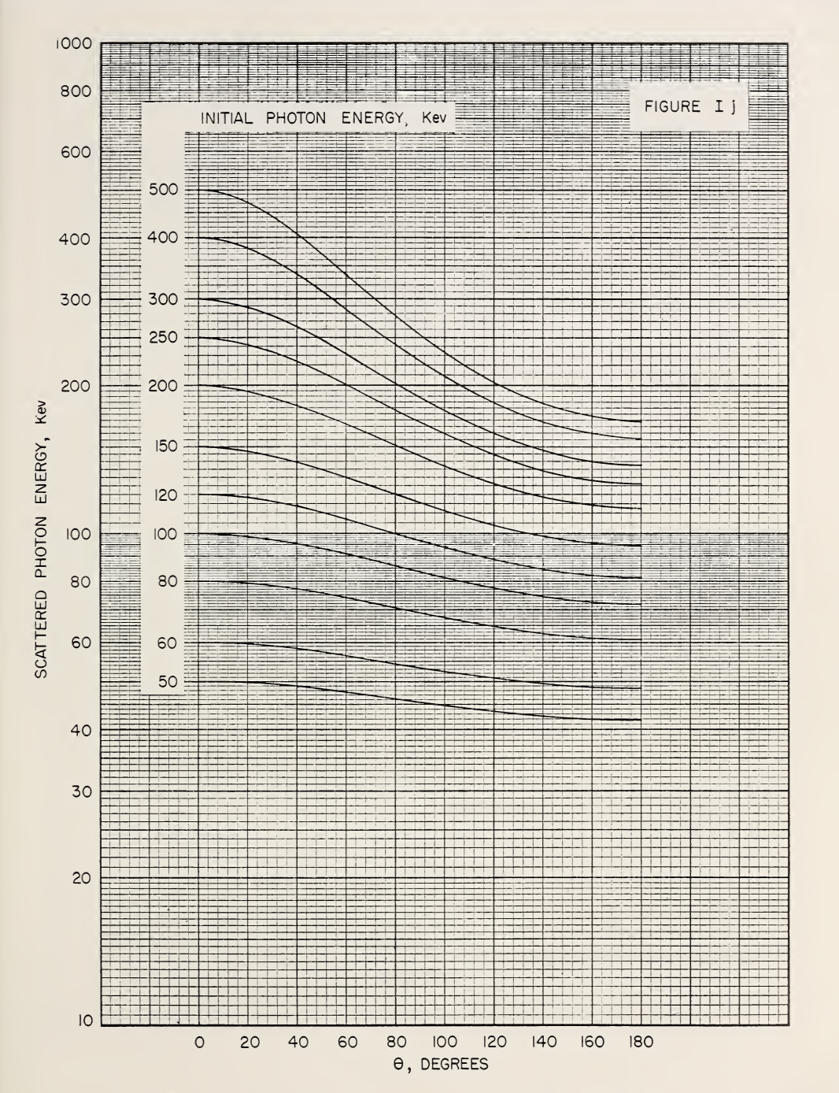

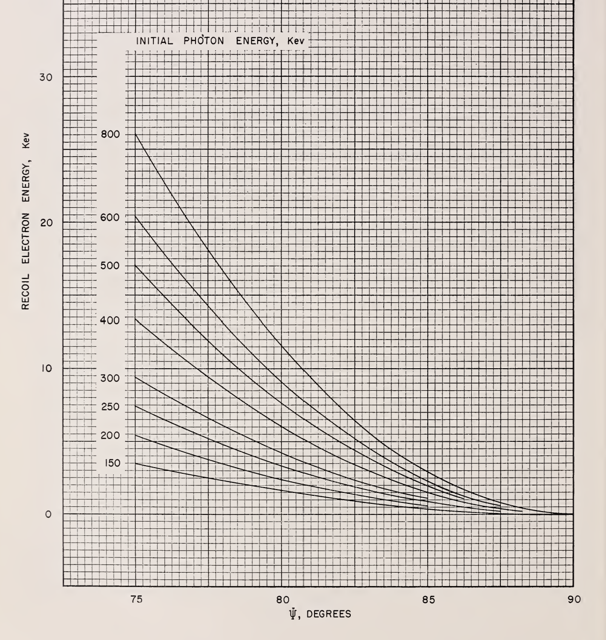

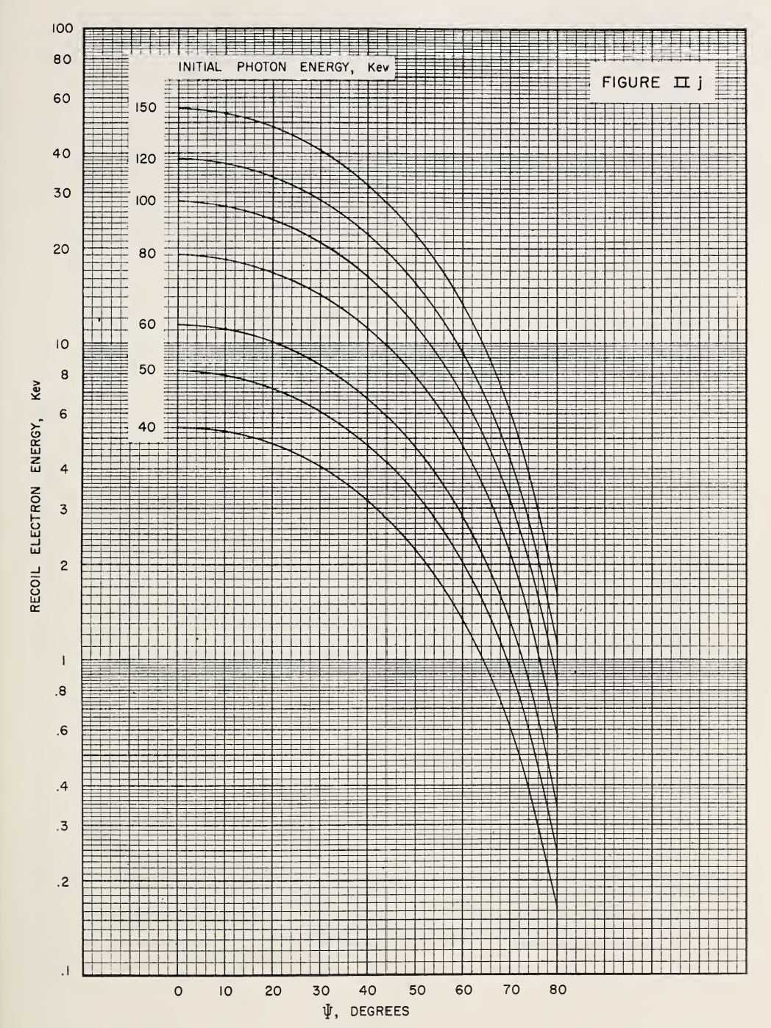

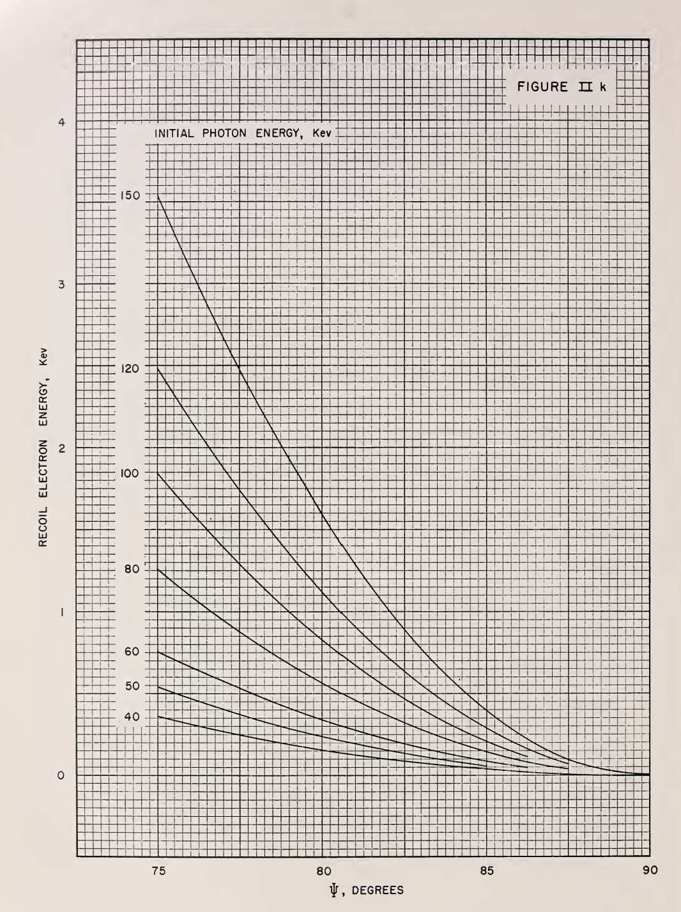

**Things to check:**

* **~~Radioactivity of the sources (in curries)~~**
* **~~Efficiency of the detectors~~**
* **Yield of the detectors (can we assume 100%?) is it dead time vs live time?**
* **Different formula for americium? Or we can just show that impulse analysis doesn’t work?**
* **Counts in vs Counts out?**

**For next iteration:**

* **Electron momentum determination**
* **Limits of impulse approximation**
* **Absorbtion**
* **Better errors**

**Paper Improvements:**

* **Separate systematic errors and statistical errors (shading for systematic, estimate (e.g. calibration**